What is EKS :-

It is managed kubernetes cluster service,which means AWS manages the master node.

It will create master node and all the nessassery apps pre-installed like container run time and master proceses.

It will rake care the scalling and backups if needed.

We are responsible for create worker node

1)enter cluster name

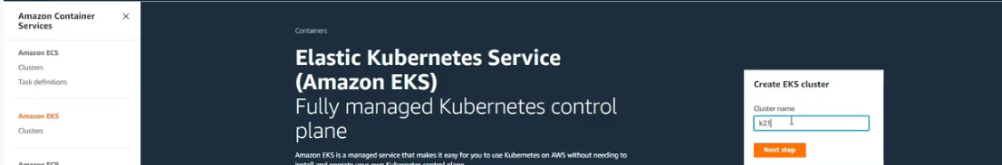

2)configure cluster

->add kubernetes latest version

->add eks cluster role

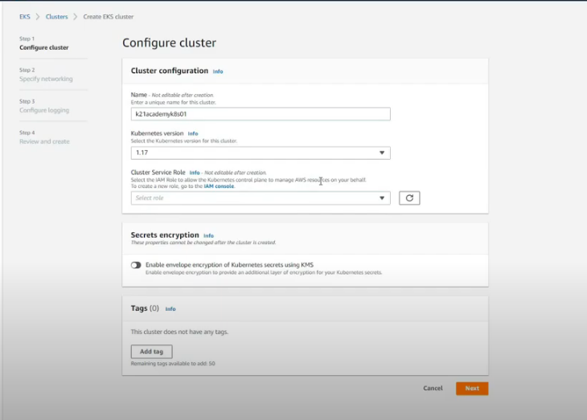

Note:-

EKS cluster role should contains below policy

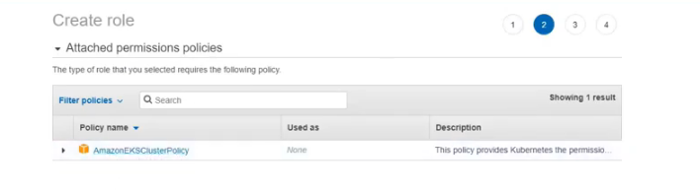

Step3:-specify networking

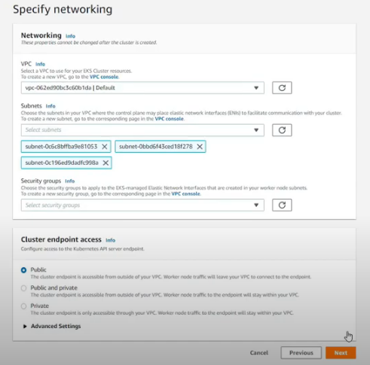

Step 4:- review the details and create the cluster

Prerequisites :-

1)install aws cli

sudo apt-get install awscli

aws –version

configure AWS accesskey and secret key

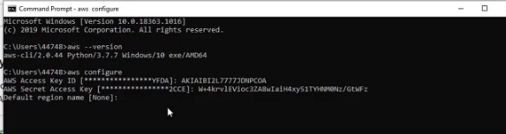

2)install kubectl

1. Update the apt package index and install packages needed to use the Kubernetes apt repository:
2. sudo apt-get update
3. sudo apt-get install -y apt-transport-https ca-certificates curl
4. Download the Google Cloud public signing key:
5. sudo curl -fsSLo /usr/share/keyrings/kubernetes-archive-keyring.gpg https://packages.cloud.google.com/apt/doc/apt-key.gpg
6. Add the Kubernetes apt repository:
7. echo "deb [signed-by=/usr/share/keyrings/kubernetes-archive-keyring.gpg] https://apt.kubernetes.io/ kubernetes-xenial main" | sudo tee /etc/apt/sources.list.d/kubernetes.list
8. Update apt package index with the new repository and install kubectl:
9. sudo apt-get update

sudo apt-get install -y kubectl

3)install iam-authenticator

Steps for ekscluster status:-



Ex :-aws eks --region eu-west-1 describe-cluster --name Genx-EKS-cluster --query cluster.status 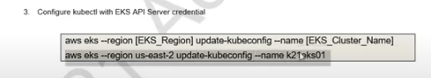

aws eks --region eu-west-1 update-kubeconfig --name Genx-EKS-cluster

Creating worker nodes:-

1)click on add node groups

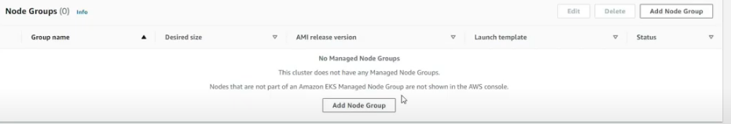

2)

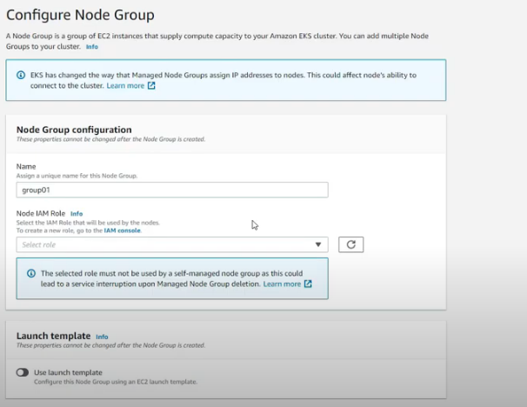

Node iam role:-



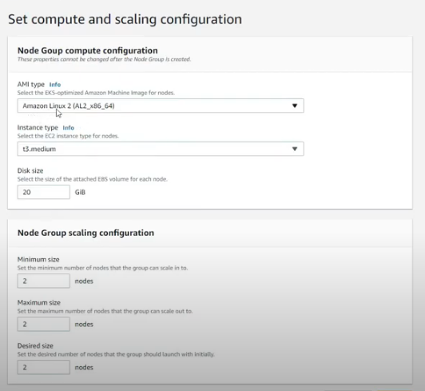

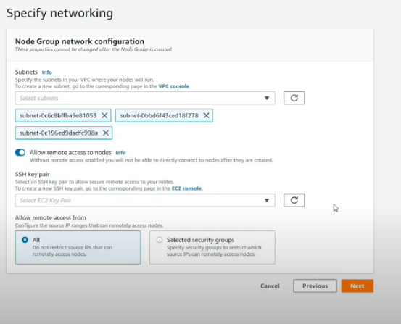

->if u unable allow remote access to node then create ssh key pair as shown(to connect with putty this will be usefull)

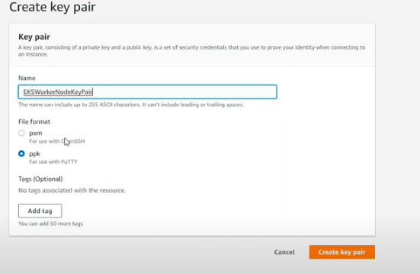

To see the workrt node

Kubectl get nodes –watch

2 ec2 instances ubuntu 18+ in public subnet...

eks cluster in private subnet